Awana Grand Prix Layout

- Play Mario Kart 64 sounds and music
- At finish line play sounds and finish music
- Show overall leader board and where the finishers are in that leader board. Ranked by average time. Show mph, time, and races for each category.
  - Example:
    - Player 1: 200 mph 1.45 sec 2/4 races
    - Player 2: 198 mph 1.50 sec 3/4 races
    - Player 3: 197 mph 1.55 sec 1/4 races
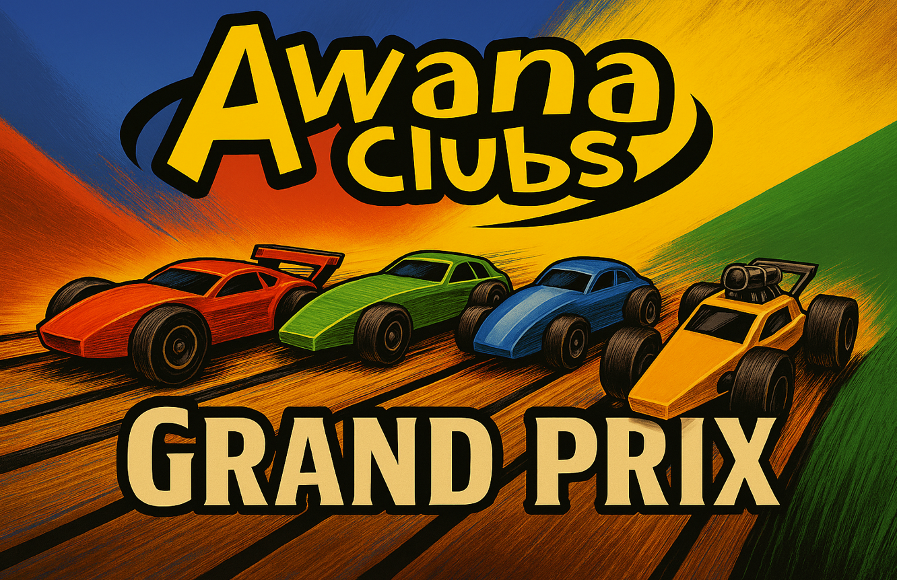
- Show Intro Screen with Awana logo with pinewood derby racing.
- Show the
  - 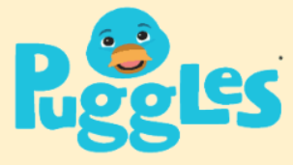
  - 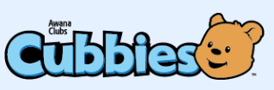
  - 
  - 
  - 
  - 
  - 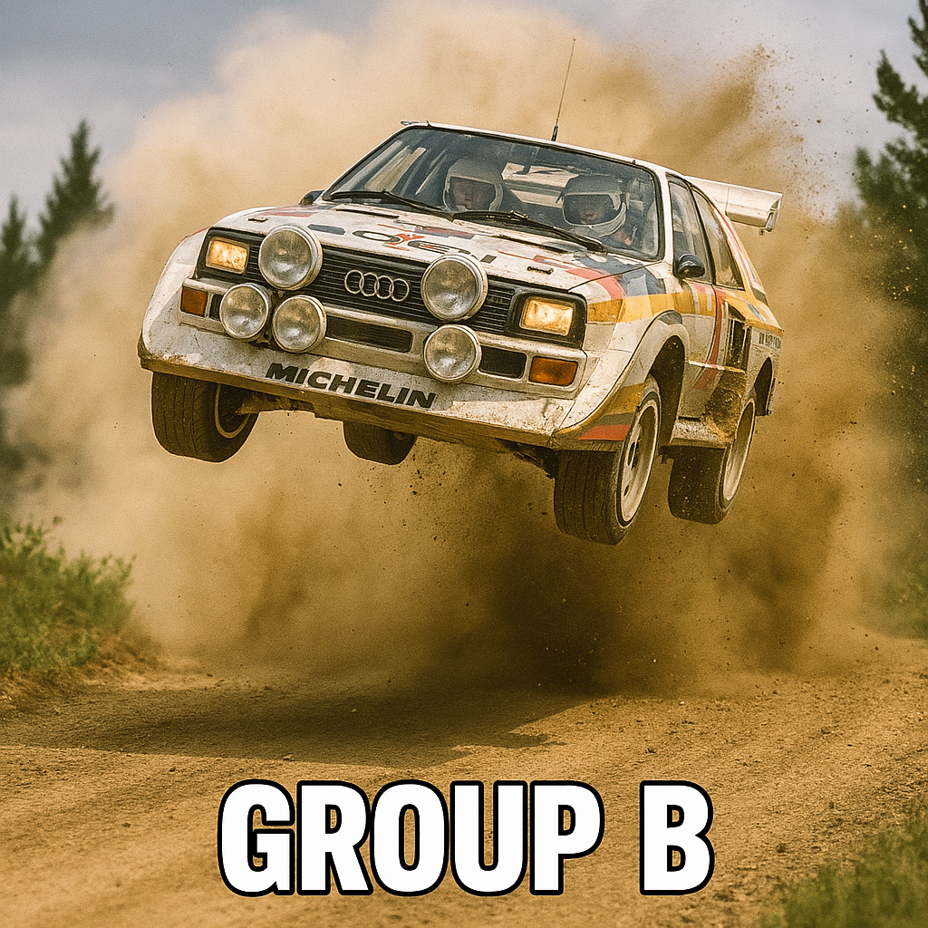
  - 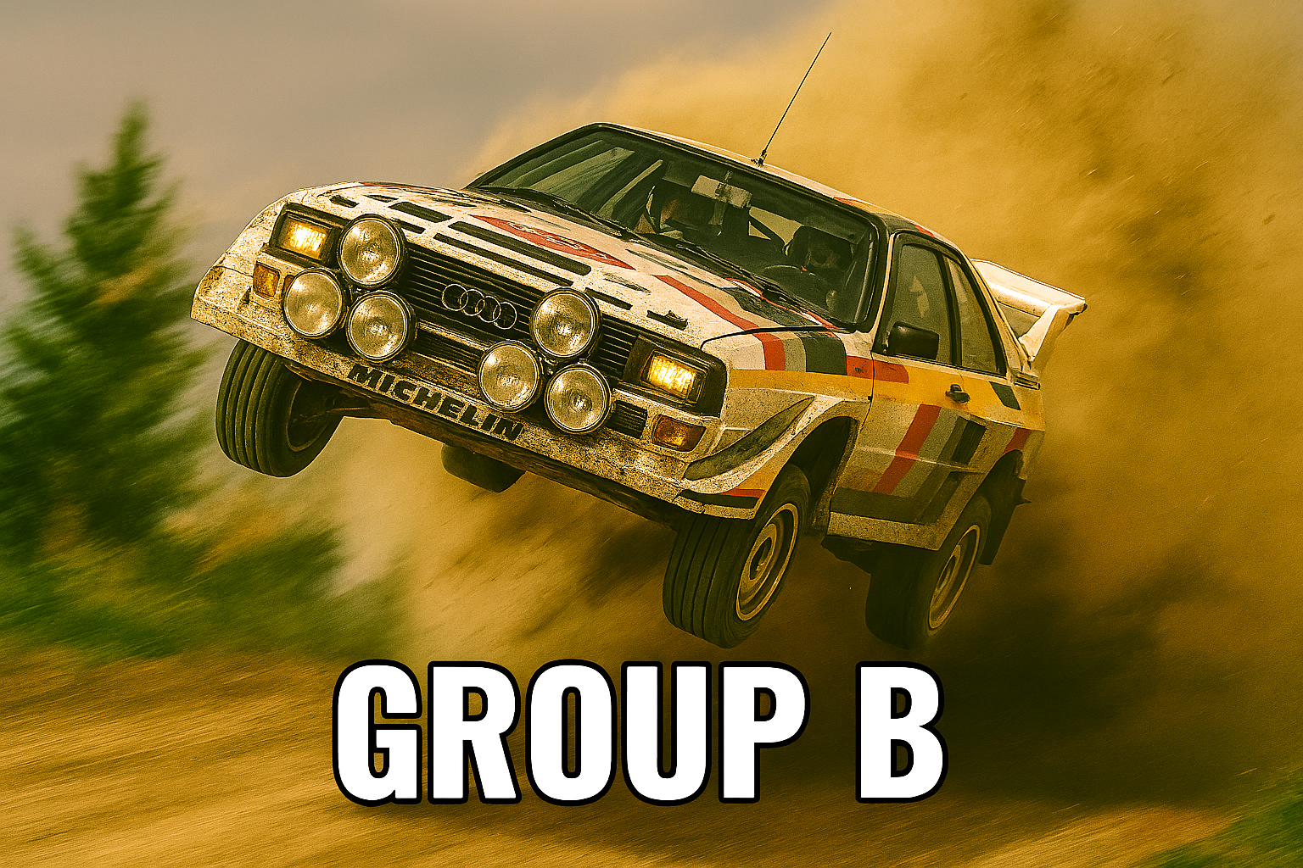
  - 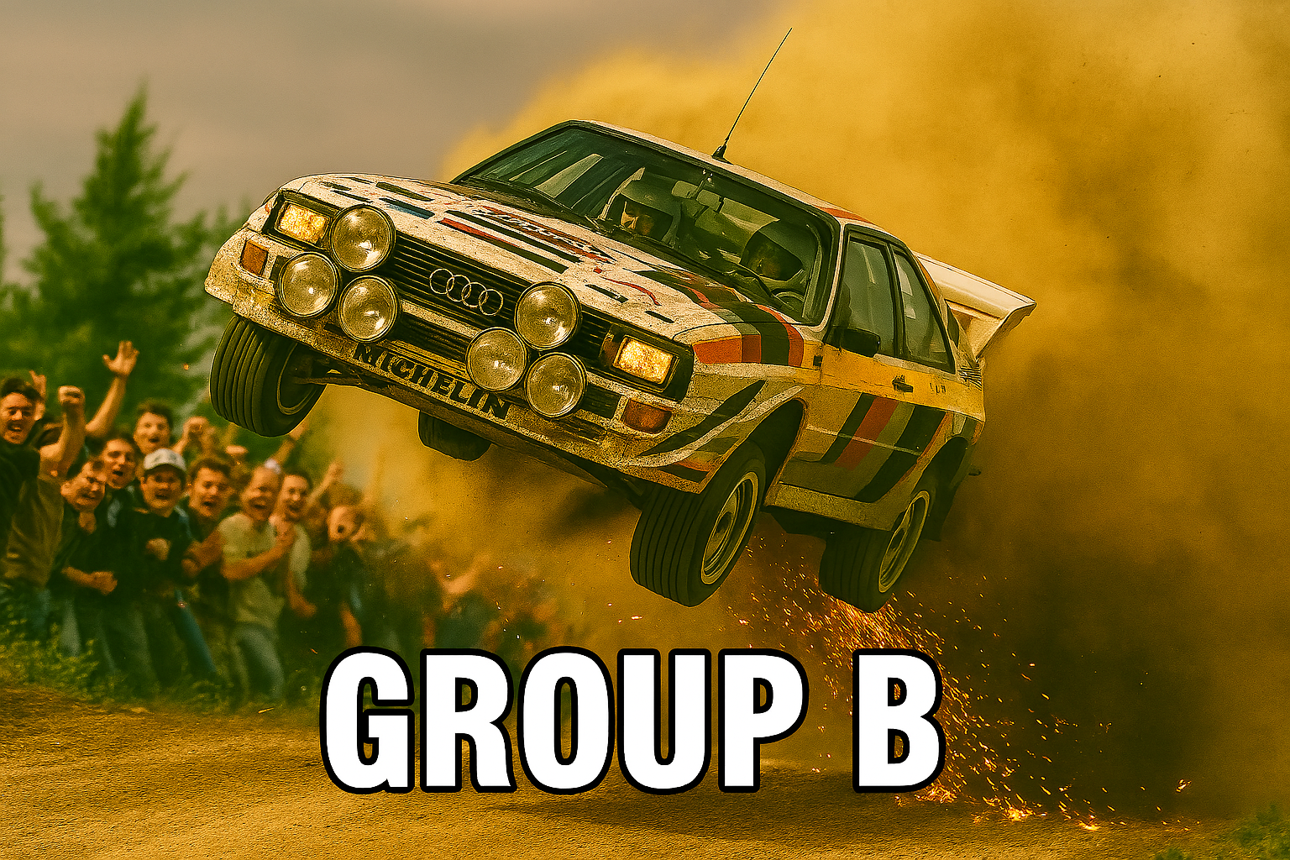

Creative Design Guide: Crafting a 10-Second Pinewood Derby Race Finish Cutscene

Introduction
The pinewood derby race finish is a moment charged with anticipation, excitement, and the culmination of effort and creativity. Capturing this in a 10-second video cutscene demands a fusion of cinematic clarity, visual drama, and instant legibility. This guide provides a comprehensive, research-driven approach to designing such a cutscene, integrating best practices from racing games, sports broadcasts, and animation, while tailoring recommendations to the unique context of pinewood derby racing. The goal is to ensure that viewers not only see the results but feel the thrill of the finish, instantly recognize the winner, and appreciate the craftsmanship behind each car.

Visual Layout and Composition
Framing the Finish: Composition Principles
The visual layout of the cutscene must prioritize clarity, excitement, and emotional impact. Drawing from visual storytelling and sports broadcast graphics, the composition should guide the viewer’s eye directly to the finish line and the cars as they cross it¹. Employing the rule of thirds, place the finish line slightly off-center, with the four cars staggered across the frame. This arrangement not only creates visual interest but also ensures that each car is distinctly visible, avoiding overlap or confusion.
Depth of field can be used strategically: a shallow focus on the finish line and cars, with the background slightly blurred, isolates the action and heightens drama. Leading lines—such as the track rails or lane markings—should converge at the finish, naturally drawing attention to the decisive moment. For added clarity, lane numbers or subtle flags can be integrated into the track design, echoing professional pinewood derby setups².
Color grading plays a crucial role in emotional pacing. A vibrant, high-contrast palette (such as teal and orange, widely used in action films and racing games) can inject energy and make the scene pop³⁴. Teal backgrounds with orange highlights on the cars and finish line create a visually striking contrast, ensuring that human elements (the cars, their details) stand out against the environment.
Multi-Panel and Split-Screen Options
To display all four track times simultaneously and emphasize the winner, consider a split-screen or multi-panel layout. This technique, common in racing games and sports broadcasts, allows viewers to compare results instantly⁵⁶. For a 10-second cutscene, a quad-panel display works well: each panel shows a close-up of a car crossing the line, with its time and lane number overlaid.
Alternatively, a dynamic bar chart race animation—where each car’s progress is visualized as an animated bar—can add excitement and clarity⁷⁸. The bars race toward the finish, with the winner’s bar bursting ahead and highlighted in a distinct color.
Example Layouts
- Single Wide Shot: All four cars cross the finish line in a single, wide-angle shot, with times appearing above each lane.
- Split-Screen Quad: The screen divides into four panels, each showing a car’s finish and time, with the winner’s panel pulsing or expanding.
- Bar Chart Race Overlay: Animated bars representing each car’s time race across the bottom of the screen, with the winner’s bar highlighted and a celebratory motif (e.g., confetti or a gold glow).
These layouts ensure that the viewer can instantly grasp the results, appreciate the drama, and celebrate the winner.

Camera Angles and Movements
Shot Selection for Maximum Impact
Camera angles are pivotal in conveying speed, competition, and clarity within a short timeframe. Drawing from cinematic car videos and sports broadcasts, the following angles are recommended for a pinewood derby finish cutscene⁹¹⁰¹¹:
- Low-Angle Finish Line Shot: Position the camera at track level, just past the finish line, angled slightly upward. This makes the cars appear larger-than-life as they cross, emphasizing their speed and the moment of victory.
- Overhead Bird’s-Eye View: A top-down shot captures all lanes simultaneously, ensuring no car is obscured. This is ideal for displaying lane numbers and times, and for split-screen or multi-panel overlays.
- Tracking Side Shot: A lateral tracking shot follows the cars as they approach and cross the finish, accentuating motion and competition. This can be combined with a speed ramp or slow-motion effect for added drama.
- Winner Zoom-In: Immediately after the finish, a quick zoom or push-in focuses on the winning car, its details, and its time, visually declaring the victor.
Camera Movements and Transitions
Dynamic camera movements—such as pans, zooms, and speed ramps—can heighten excitement and guide viewer focus¹²¹³. For a 10-second cutscene, use:
- Speed Ramp: Begin at real-time speed as the cars approach the finish, then ramp into slow motion for the final crossing. This technique, popular in racing games and cinematic trailers, emphasizes the tension and precision of the finish¹²¹³.
- Quick Cut Montage: Rapid cuts between different angles (side, overhead, close-up) create a sense of urgency and competition, mirroring the editing style of sports broadcasts and game cinematics¹⁴¹.
- Split-Screen Reveal: As the cars cross, transition to a split-screen showing each car’s finish in close-up, then merge back to a single frame for the winner announcement.
Practical Shooting Tips
For indoor pinewood derby events, ensure consistent lighting to avoid flicker and maintain clarity¹⁵¹⁶. Use LED panels or softboxes to evenly illuminate the track, and position cameras on tripods or sliders for stable, smooth motion. If possible, employ a gimbal for tracking shots, and test angles beforehand to avoid obstructed views.

Storyboard and Shot List for a 10-Second Sequence
Frame-by-Frame Breakdown
A well-structured storyboard is essential for pacing and clarity. Below is a sample shot list for a 10-second pinewood derby finish cutscene, integrating the recommended visual and cinematic techniques¹⁷¹¹¹⁶:
Time (s) | Shot Description | Camera Angle | Action/Effect | Overlay/Text
0.0–1.0 | Establishing shot of track and finish line | Wide, low-angle | Cars approach finish | Race logo, event name
1.0–2.5 | Tracking side shot of cars | Side, tracking | Cars accelerate | Subtle motion blur
2.5–4.0 | Speed ramp into slow motion as cars cross finish | Low-angle, finish line | Dramatic slow-mo | Lane numbers appear
4.0–5.5 | Split-screen quad panels: each car’s finish | Four close-ups | Times animate in | Animated digital counters
5.5–7.0 | Winner zoom-in: push-in on winning car | Close-up, dynamic zoom | Winner highlight | “Winner!” stinger, gold glow
7.0–8.5 | Bar chart race overlay: animated bars show times | Overlay, bottom third | Bars animate, winner bar bursts ahead | Times update, winner bar pulses
8.5–10.0 | Celebration: confetti, crowd cheer, fade out | Wide shot, slight tilt | Winner car glows, crowd SFX | Final leaderboard, sponsor logo
Storyboard Principles
Each shot should be planned to maximize clarity and emotional impact. Use thumbnail sketches to block out key frames, ensuring that transitions are smooth and that overlays do not obscure critical action¹¹¹⁶. Timing is crucial: allow enough linger on the winner for celebration, but keep the sequence punchy and energetic.

Animation Pacing and Editing Rhythm
Visual Pacing for Punchy Impact
In a 10-second cutscene, every frame counts. The rhythm should be fast enough to convey excitement, but not so rapid that viewers miss the results¹⁸¹⁴. Employ the following pacing strategies:
- Quick Build-Up: The first 2 seconds set the stage, building anticipation as the cars approach the finish.
- Slow-Motion Climax: The next 1.5 seconds slow down the action, allowing viewers to savor the decisive moment.
- Rapid Reveal: Split-screen and bar chart overlays animate in quickly (1.5 seconds), delivering results with visual flair.
- Winner Emphasis: The winner’s highlight and celebration occupy the final 3 seconds, ensuring the victory is clear and memorable.
Editing should synchronize with audio cues—such as a rising musical stinger or crowd cheer—to reinforce emotional beats¹⁹. Use rhythmic cuts aligned with the soundtrack, and avoid abrupt transitions that could confuse viewers.
Animation Curves and Micro-Animations
Micro-animations—such as digital counters flipping, progress bars racing, or ticks appearing next to times—add polish and legibility²⁰²¹. Employ easing curves (e.g., ease-in for anticipation, ease-out for celebration) to make movements feel natural and engaging.
For text and numbers, animate their appearance with a brief “pop” or “flip” effect, drawing attention without overwhelming the viewer. The winner’s time can pulse or glow, while losing times fade slightly to direct focus.

Slow Motion and Speed Ramping Techniques
Enhancing Drama with Speed Control
Slow motion and speed ramping are powerful tools for emphasizing the critical moment of the finish¹²¹³. In the context of a pinewood derby cutscene:
- Traditional Slow Motion: Use a brief slow-motion segment (0.5–1.5 seconds) as the cars cross the finish. This allows viewers to appreciate the closeness of the race and the craftsmanship of each car.
- Speed Ramping: Transition smoothly from real-time to slow motion and back, using a ramped curve rather than a sudden change. This technique, popularized in racing games and cinematic trailers, creates a dynamic flow and heightens tension¹²¹³.
When applying slow motion, ensure that the frame rate is high enough (ideally 60fps or higher) to maintain clarity and avoid stutter¹⁶. Synchronize slow-motion segments with audio cues—such as a dramatic drum hit or crowd gasp—for maximum impact.
When to Use Each Technique
- Slow Motion: Best for emphasizing the finish itself, especially in close races or when highlighting car details.
- Speed Ramping: Ideal for transitions between build-up, climax, and celebration, guiding the viewer’s emotional journey.
Use these effects sparingly; overuse can dilute their impact and slow the pacing of the cutscene.

Split-Screen, Multi-Angle, and Multi-Panel Displays
Comparative Clarity and Excitement
Split-screen and multi-panel displays are effective for showing multiple results simultaneously, a technique borrowed from racing games and sports broadcasts⁵²²⁶. For a pinewood derby finish:
- Quad Split-Screen: Divide the screen into four panels, each showing a car’s finish and time. This allows instant comparison and ensures no car is overlooked.
- Multi-Angle Replay: Briefly cut between different angles (side, overhead, close-up) to showcase the finish from multiple perspectives, adding excitement and depth.
- Bar Chart Race: Animate bars representing each car’s time, racing across the screen and culminating in the winner’s bar bursting ahead⁷⁸.
These techniques enhance legibility and drama, making the results clear and engaging.
Accessibility Considerations
Ensure that text overlays and animated elements are large, high-contrast, and readable even on small screens²³²⁴. Use accessible fonts (e.g., Open Sans, Helvetica, Georgia) and avoid overly decorative typefaces that could hinder comprehension.

Text Overlays and Typography for Results Display
Designing for Legibility and Impact
Displaying four track times clearly and instantly is a core requirement. The following principles ensure that text overlays are both legible and visually appealing:
- Font Choice: Use sans-serif fonts with high x-height and clear letterforms (e.g., Open Sans, Helvetica, Roboto) for maximum readability at small sizes²³²⁴.
- Contrast: Overlay text in white or bright colors against dark backgrounds, or vice versa, to ensure visibility. Employ drop shadows or subtle outlines to separate text from busy backgrounds.
- Hierarchy: Make the winner’s time larger, bolder, and highlighted (e.g., gold or orange), while other times are slightly smaller or desaturated.
- Animation: Animate times as digital counters flipping or ticking in, adding excitement and drawing attention²⁰²¹.
Layout Strategies
- Lane Numbers: Display lane numbers prominently next to each time, using color-coded icons or badges for quick identification.
- Winner Highlight: Add a “Winner!” badge, gold glow, or animated stinger next to the winning time, ensuring instant recognition.
- Leaderboard Overlay: At the end of the cutscene, display a final leaderboard with all four times, winner highlighted, and sponsor logos if desired.
Accessibility and WCAG Compliance
Ensure that color contrast meets WCAG 2.1 AA standards for accessibility, and that font sizes are sufficient for comfortable reading on all devices²³²⁴. Avoid color combinations that could be problematic for colorblind viewers (e.g., red/green without additional cues).

Visual Motifs, Color Grading, and Iconography
Motifs for Drama and Clarity
Visual motifs—such as checkered flags, confetti, gold glows, or speed lines—can enhance the drama and celebration of the finish³²⁵. Use these elements sparingly to avoid clutter, focusing on the winner’s moment.
Color grading should reinforce the emotional tone: vibrant teals and oranges for energy, gold for victory, and cool blues for calmness. The teal and orange look, popular in action films and racing games, creates a dynamic contrast that draws attention to the cars and results³⁴.
Iconography—such as lane badges, winner crowns, or digital ticks—adds clarity and visual interest. Ensure that icons are simple, universally recognizable, and do not obscure critical information.
Example Color Palettes
- Teal and Orange: Teal backgrounds with orange highlights on cars and winner overlays.
- Gold and Navy: Gold glow for the winner, navy for background and text.
- Black and Yellow: High-contrast black background with yellow text and icons for instant legibility.
Choose palettes that align with the event’s branding and enhance readability²⁵²⁶.

Sound Design: SFX, Stingers, and Crowd Cues
Audio for Emotional Impact
Sound design is integral to pacing and excitement. The following audio elements are recommended for a 10-second pinewood derby finish cutscene:
- Race Ambience: Subtle background sounds of rolling wheels, track clatter, and crowd anticipation set the scene.
- Finish Line Stinger: A dramatic musical cue or fanfare as the cars cross the finish, synchronized with slow-motion or speed ramp effects¹⁹²⁷²⁸²⁹.
- Digital Tick or Counter SFX: As times appear, use digital ticking or flipping sounds to reinforce the animation.
- Winner Celebration: Crowd cheer, confetti burst, or a triumphant musical hit as the winner is revealed.
- Fade-Out: A soft musical outro or applause as the leaderboard appears and the cutscene ends.
Choose royalty-free sound effects and music to ensure legal compliance and ease of prototyping¹⁹²⁸²⁹.
Synchronization with Visuals
Align audio cues with key visual moments—e.g., a rising stinger as the cars approach, a dramatic hit at the finish, and a celebratory cheer for the winner. Use audio to reinforce pacing, guide viewer emotion, and enhance clarity¹⁹.

Examples from Racing Games and Sports Broadcasts
Racing Games
Modern racing games employ a variety of cinematic techniques to make finishes exciting and clear:
- Split-Screen Results: Games like F1, Mario Kart, and Blur use split-screen or multi-panel displays to show results instantly, often with animated overlays and winner highlights⁵²².
- Speed Ramp and Slow Motion: Dramatic slow-motion replays of photo finishes, with speed ramp transitions, heighten tension and allow viewers to appreciate close races¹²¹³.
- Bar Chart Race Overlays: Animated bars race across the screen, visualizing progress and results in real time⁷⁸.
Sports Broadcasts
Professional broadcasts use advanced graphics and overlays to display results:
- Live Leaderboards: Dynamic leaderboards update in real time, with winner highlights and sponsor integration⁶.
- Photo Finish Technology: High-speed cameras and composite images determine winners in close races, with overlays showing times and positions⁹¹⁰.
- Crowd and SFX Integration: Audio cues—cheers, stingers, and applause—are synchronized with visual highlights for maximum impact¹⁹²⁸²⁹.
These examples provide a rich source of inspiration for pinewood derby cutscene design.

On-Screen Timing and Animation Curves for Text and Numbers
Timing Breakdown
Precise timing ensures that viewers can absorb results without confusion. For a 10-second cutscene:
- 0.0–2.5s: Build-up and approach (establishing shot, tracking, anticipation).
- 2.5–4.0s: Slow-motion finish (cars cross, dramatic pause).
- 4.0–5.5s: Results reveal (split-screen, times animate in).
- 5.5–7.0s: Winner highlight (zoom-in, celebration).
- 7.0–8.5s: Bar chart race overlay (animated bars, winner bar pulses).
- 8.5–10.0s: Leaderboard and fade-out (final results, sponsor logo).
Animation curves should use ease-in for anticipation, ease-out for celebration, and linear for progress bars and counters²⁰²¹.
Micro-Animations
- Digital Counter Flip: Each time appears with a flipping animation, accompanied by a ticking SFX.
- Progress Bar Race: Bars animate smoothly, with the winner’s bar bursting ahead and pulsing.
- Winner Glow: The winning time glows or pulses, drawing attention.
These micro-animations add polish and enhance legibility.

Legibility and Accessibility for Quick Result Comprehension
Best Practices
- Font Size: Ensure text is large enough for comfortable reading on all devices.
- Contrast: Use high-contrast color schemes for overlays and backgrounds.
- Font Choice: Select fonts with clear letterforms and high x-height (Open Sans, Helvetica, Georgia)²³²⁴.
- Color Coding: Use distinct colors for each lane and winner highlight, with additional icons or badges for clarity.
- WCAG Compliance: Meet accessibility standards for color contrast and font size.
Test overlays on various screen sizes and lighting conditions to ensure universal legibility.

Motion Graphics Templates and Tools
Recommended Tools
- Adobe After Effects: Industry-standard for motion graphics, with templates for leaderboards, split-screen overlays, and animated counters³⁰³¹.
- Unity: Real-time engine for interactive and animated cutscenes, suitable for pinewood derby simulations.
- Flourish Studio: For animated bar chart races and data-driven overlays⁷.
- Replay It, Spiideo Perform: For multi-angle video feedback and split-screen analysis in sports contexts.
Leverage royalty-free templates and assets for rapid prototyping and customization.

Camera Rigs and Practical Shooting Tips for Indoor Pinewood Derby
Equipment Recommendations
- Cameras: Use 4K resolution cameras with 60+ fps for smooth slow-motion playback and detailed captures¹⁵¹⁶.
- Tripods and Sliders: Ensure stable, smooth motion for tracking and low-angle shots.
- Lighting: Employ LED panels or softboxes for even, flicker-free illumination.
- Gimbals: For dynamic tracking shots, use a gimbal to maintain stability.
- Finish Line Sensors: Integrate IR sensors or photo finish cameras for precise timing and overlays¹⁵⁹¹⁰.
Test setups before the event to avoid technical issues and ensure optimal angles.

Comparative Table: Cinematic Techniques for Pinewood Derby Finish Cutscene
Technique | Pros | Cons | Best Use Case
Split-Screen | Instant comparison, clear results | Can feel busy, may reduce drama | Displaying all four times at once
Slow Motion | Heightens drama, emphasizes finish | Can slow pacing, overuse dilutes impact | Climax of finish, close races
Speed Ramping | Dynamic transitions, guides emotion | Requires careful timing, can confuse | Build-up and release of tension
Zoom-In | Focuses on winner, adds excitement | May obscure other results | Winner reveal and celebration
Bar Chart Race | Visualizes progress, engaging animation | May distract from actual footage | Animated results overlay
Multi-Angle Replay | Adds depth, showcases craftsmanship | Requires more footage, editing complexity | Highlighting car details, close-ups
Digital Counter | Clear, modern, instant legibility | Can feel sterile without context | Displaying times and leaderboard
Each technique offers unique strengths and should be chosen based on the desired emotional impact, clarity, and pacing of the cutscene.

Color, Typography, and Iconography Choices for Winner Emphasis
Color
- Gold or Orange: For winner highlights, use gold or vibrant orange glows, backgrounds, or badges³⁴²⁵.
- Teal and Navy: For backgrounds and overlays, use teal or navy for contrast and energy.
- High-Contrast Combinations: Ensure text and icons stand out against backgrounds (e.g., white on navy, black on yellow).
Typography
- Bold, Sans-Serif Fonts: Use bold weights for winner times and badges (Open Sans, Helvetica, Roboto).
- Large, Clear Numbers: Display times in large, easily readable digits.
- Distinct Lane Labels: Use color-coded lane numbers or icons for quick identification.
Iconography
- Winner Crown or Badge: Add a crown, trophy, or “Winner!” badge next to the winning time.
- Animated Ticks: Use animated ticks or checkmarks for verified results.
- Confetti or Glow: Overlay confetti bursts or glowing effects for celebration.
These choices ensure that the winner is instantly recognized and celebrated.

Micro-Animations for Each Car Time (Bars, Progress, Ticks)
Implementation
- Progress Bars: Animate bars racing across the screen, with the winner’s bar bursting ahead and pulsing.
- Digital Counter Flip: Times appear with a flipping animation, accompanied by ticking SFX.
- Animated Ticks: Verified results receive animated ticks or checkmarks.
- Winner Pulse: The winner’s time pulses or glows, drawing attention.
These micro-animations add polish, excitement, and clarity to the results display.

Timing Breakdown Per Frame for a 10-Second Cutscene
Time (s) | Action/Shot | Animation/Overlay | Audio Cue
0.0–1.0 | Establishing shot, cars approach | Race logo, event name | Rising ambience
1.0–2.5 | Tracking side shot | Subtle motion blur | Wheels, crowd murmur
2.5–4.0 | Slow-motion finish | Lane numbers appear | Dramatic stinger
4.0–5.5 | Split-screen quad panels | Times animate in | Digital ticks
5.5–7.0 | Winner zoom-in | Winner badge, gold glow | Crowd cheer
7.0–8.5 | Bar chart race overlay | Animated bars, winner pulse | Fanfare, confetti
8.5–10.0 | Leaderboard, fade-out | Final results, sponsor logo | Applause, outro
This breakdown ensures that each moment is paced for maximum clarity and excitement.

Templates and Royalty-Free Assets for Quick Prototyping
Recommended Resources
- After Effects Leaderboard Templates: For animated results overlays and split-screen displays³⁰³¹.
- Flourish Bar Chart Race Templates: For animated bar chart race overlays⁷.
- Replay It, Spiideo Perform: For multi-angle video feedback and split-screen analysis.
- Pixabay, Pond5: For royalty-free sound effects, stingers, and crowd cues¹⁹²⁸²⁹.
- Canva, Envato Elements: For color palette inspiration, icons, and branding assets²⁶³¹.
Leverage these resources for rapid prototyping and customization, ensuring professional-quality results.

Conclusion: Integrating Cinematic Techniques for an Unforgettable Finish
Designing a 10-second pinewood derby race finish cutscene is a creative challenge that demands clarity, excitement, and instant legibility. By integrating best practices from racing games, sports broadcasts, and visual storytelling, you can craft a sequence that not only displays results but celebrates the spirit of competition and craftsmanship.
Prioritize visual layout and composition for clarity, use dynamic camera angles and movements to heighten drama, and employ split-screen and bar chart overlays for instant comparison. Animate text and numbers with micro-animations and synchronize audio cues for emotional impact. Choose colors, typography, and iconography that emphasize the winner and ensure accessibility for all viewers.
With careful planning, precise timing, and the right tools and assets, your pinewood derby finish cutscene will be both exciting and clear—leaving viewers eager for the next race.

Comparative Table: Cinematic Techniques for Pinewood Derby Finish Cutscene
Technique | Pros | Cons | Best Use Case
Split-Screen | Instant comparison, clear results | Can feel busy, may reduce drama | Displaying all four times at once
Slow Motion | Heightens drama, emphasizes finish | Can slow pacing, overuse dilutes impact | Climax of finish, close races
Speed Ramping | Dynamic transitions, guides emotion | Requires careful timing, can confuse | Build-up and release of tension
Zoom-In | Focuses on winner, adds excitement | May obscure other results | Winner reveal and celebration
Bar Chart Race | Visualizes progress, engaging animation | May distract from actual footage | Animated results overlay
Multi-Angle Replay | Adds depth, showcases craftsmanship | Requires more footage, editing complexity | Highlighting car details, close-ups
Digital Counter | Clear, modern, instant legibility | Can feel sterile without context | Displaying times and leaderboard
Each technique offers unique strengths and should be chosen based on the desired emotional impact, clarity, and pacing of the cutscene.

References
This guide synthesizes insights from a wide range of sources, including cinematic car video editing tutorials, pinewood derby recording tips¹⁵³², sports broadcast graphics methodologies⁶, racing game finish line compilations⁵²², visual storytelling and pacing theory¹⁸¹¹¹⁶, color grading guides³⁴²⁵²⁶, sound design resources¹⁹²⁷²⁸²⁹, and motion graphics templates³⁰³¹⁷⁸. The recommendations are tailored for the pinewood derby context, ensuring both professional polish and accessibility.

Design your cutscene with intention, and let the finish line become a moment of cinematic triumph—clear, exciting, and unforgettable.

References (32)
1Film Techniques List for English Analysis | Updated for 2025. https://www.matrix.edu.au/essential-guide-english-techniques/ultimate-film-techniques-list/
2Pinewood Derby Track SuperTrack Finish. https://www.supertimer.com/track/trackfinish.html
3Mastering Teal & Orange Film Look: A Comprehensive Guide. https://www.cinema-luts.com/teal-and-orange/
4Color Grading: The Teal and Orange (Analysis of a Look). https://www.mauriziomercorella.com/color-grading-blog/color-grading-teal-and-orange-analysis-of-a-look
5Best Split-screen racing games - GG.deals. https://gg.deals/games/split-screen-racing/
6iRacing Overlays, live timing, live streaming and much more. https://www.sdk-gaming.co.uk/
7Make a bar chart race without coding | Flourish. https://flourish.studio/visualisations/bar-chart-race/
8How to Create Animated Bar Chart Race in Excel (with Easy Steps). https://www.exceldemy.com/animated-bar-chart-race-excel/
9The NASCAR Camera Tech Behind a Historic 0.001s Photo Finish. https://petapixel.com/2024/05/08/the-nascar-camera-tech-behind-a-historic-0-001s-photo-finish/
10Photo Finish In Photography: Capturing the Decisive Moment in Sports. https://filmlifestyle.com/photo-finish-in-photography/
11How to Storyboard Action Scenes: Mastering Timing, Framing, and Flow. https://voxillustration.com/blog/how-to-storyboard-action-scenes/
12Speed Ramping vs Traditional Slow Motion: What To Know. https://nerdtechy.com/speed-ramping-vs-traditional-slow-motion
13How to Use the Speed Ramp Effect (with Examples) - Kapwing. https://www.kapwing.com/resources/how-to-use-the-speed-ramp-effect/
14Top 10 Best Game Cinematics That Will Impress You!. https://animost.com/ideas-inspirations/best-game-cinematics/
15Introduction: Pinewood Derby Race Finish Line - Instructables. https://www.instructables.com/Introduction-Pinewood-Derby-Race-Finish-Line/
16Frame by Frame Animation: Breathing Life into the Still. https://darkskiesfilm.com/how-to-make-a-frame-by-frame-animation/
17Free Customizable Shot List Templates - Highfile. https://www.highfile.com/documents/list-templates/shot-lists/
18Visual storytelling: Visual Pacing: Controlling the Rhythm of Your .... https://fastercapital.com/content/Visual-storytelling--Visual-Pacing--Controlling-the-Rhythm-of-Your-Visual-Story.html
19Free Stinger Sound Effects Download - Pixabay. https://pixabay.com/sound-effects/search/stinger/
20Number Counter | Modern UI. https://modern-ui.org/docs/components/number-counter
21Fliping Digital Counter | BuouUI. https://buouui.com/docs/animations/fliping-counter
22What Are the Best Split-Screen Racing Games? - Hardcore Gamer. https://hardcoregamer.com/best-split-screen-racing-games/
23The 24 Best Fonts for Small Text - Design Your Way. https://www.designyourway.net/blog/best-fonts-for-small-text/
2417+ of the Easiest Fonts to Read (Most Legible Fonts). https://justcreative.com/easiest-fonts-to-read/
2518+ Best Color Combinations For Designers in 2025 | Professional Guide. https://www.victorflow.com/blog/best-color-combinations-for-designers
26100 color combination ideas and examples | Canva. https://www.canva.com/learn/100-color-combinations/
27Freesound - Finish Line Stinger by SterlingRay. https://freesound.org/people/SterlingRay/sounds/718483/
28Free Finish Line Sound Effects Download - Pixabay. https://pixabay.com/sound-effects/search/finish line/
29finish line Royalty-Free Sound Effects - Pond5. https://www.pond5.com/search?kw=finish-line&media=sfx
30Leaderboard After Effects Templates | VideoHive. https://videohive.net/category/after-effects-project-files?term=leaderboard
31After Effects Leaderboard Broadcast Templates - Editable Broadcast .... https://elements.envato.com/video-templates/broadcast-packages/leaderboard/compatible-with-after-effects
32Top 5 Performance Tips for Winning Your Pinewood Derby Race. https://performance-pinewood.com/top-5-performance-tips-for-winning-your-pinewood-derby-race/

